Read the news or a book

Research something you’ve always wondered about

Go to a museum

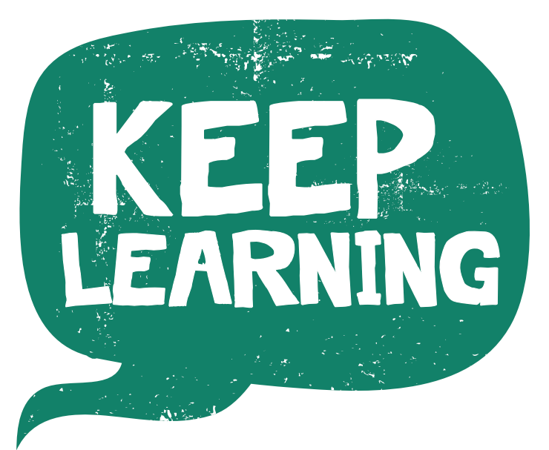

Visit your local library

Go to a quiz or host one among your friends

Learn a new dance routine or the words too a new song

Learn a new hobby or a new language

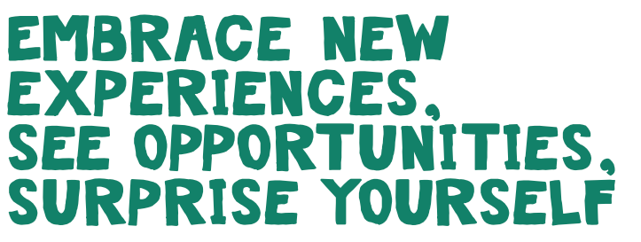

Learn a new word

Download a random fact app

Learn an inspirational quote