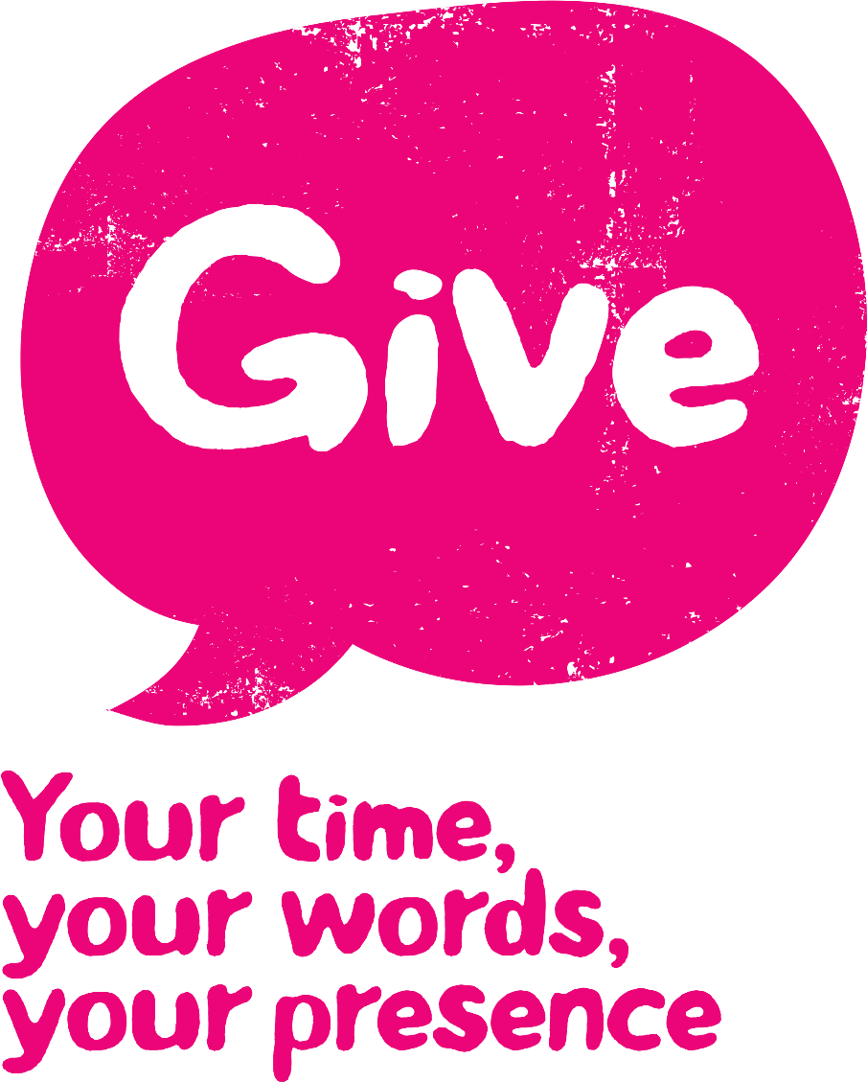

Give someone in your family a hug - just because you can!

Arrange a day out for you and a friend/relative

Volunteer some time to help someone out- i.e. a grandparent or a friend

Lend a hand in the kitchen OR cook a meal

Tidy your bedroom- without being asked!

Get involved in some charity work

**‘Cause doing good, does you good**

Pay someone a compliment

Open a door if someone is struggling with lots to carry

Volunteer in the community i.e. help out younger kids at alocal youth group

Message a friend you haven’t spoken to in a while

Load/unload the dishwasher