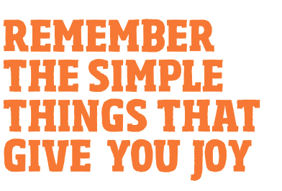

Watch animals and birds outside

Take notice of what you are thinking

Reflect on the positives in life and what you can be grateful for

Think about who inspires you, and why

Consider your strengths and how you make the most of them

Notice nature around you and how it makes you feel

Think about what your loved ones do for you

Stop and really take in your surroundings